

**“UIC: UNIVERSITY INSTITUTE OF COMPUTING”**

**SUBJECT : R PROGRAMMING LAB**



**Topic Name -** **"Analyzing and Visualizing Student Scores in R"**

**SUBMITTED BY:- SUBMITTED TO:-**

STUDENT NAME: Vinayak Kaushik TEACHER NAME : MS. SHIVANI CHADHA

BRANCH :- BCA(DATA SCIENCE) SUB CODE :- 24CAP-161

UID :- 24BCD10110 SECTION :- 24BCD-3(A)

SEMESTER :- 2nd

"Analyzing and Visualizing Student Scores in R"

**1. Aim**  
  
To develop an R program for performing statistical analysis and graphical visualization of student scores in various subjects.

**2. Objective**

* To analyze marks of students across different subjects using basic statistics in R.
* To visualize the score distribution using graphs such as bar charts, histograms, and box plots.
* To extract insights from data such as identifying top and bottom scorers

**3. Input and Output Parameters**  
  
Input:  
  
A dataset (CSV format) containing student names and their scores in subjects like Math, Science,Arts and English.  
Output:

* A summary table of student scores
* Statistical metrics (mean, median, SD) for each subject
* Visual representations: bar plot, histogram, box plot
* Insights: highest and lowest scorers, performance comparisons

**4. Procedure**  
1. Load the dataset into R.

2. Perform exploratory data analysis to check for missing or incorrect values.

3. Use summary() and functions like mean(), median(), and sd() to compute statistics.  
  
4. Use visualization packages like ggplot2 or base R plotting functions.

5. Identify and print top and bottom scorers for each subject.

6. Interpret and record the output insights..

"Analyzing and Visualizing Student Scores in R"

**5. Source Code** (With Explanations)  
  
# Load necessary libraries  
library(ggplot2)  
  
# Step 1: Read the dataset

data<-[read.csv](http://read.csv)("C//Users//mdtah//Downloads//Academia//R//[student_scores.csv](http://student_scores.csv)")  
print(data)  
  
# Step 2: Summary statistics  
summary(data)  
mean(data$Math)  
median(data$Math)  
sd(data$Math)  
  
# Repeat for other subjects...  
  
# Step 3: Visualization  
# Bar Plot  
barplot([as.matrix](http://as.matrix)(data[,-1]), beside=TRUE, col=rainbow(3),  
        legend = colnames(data[,-1]), main="Student Scores")  
  
# Histogram for Math  
hist(data$Math, col="lightblue", main="Distribution of Math Scores", xlab="Scores")  
  
# Boxplot  
boxplot(data[, -1], main="Boxplot of Scores", col=rainbow(3))  
  
# Step 4: Highest and Lowest Scorers  
max_math <- data[[which.max](http://which.max)(data$Math), ]  
min_math <- data[[which.min](http://which.min)(data$Math), ]  
print(paste("Topper in Math:", max_math$Name))  
print(paste("Lowest in Math:", min_math$Name))

**6. Outputs**

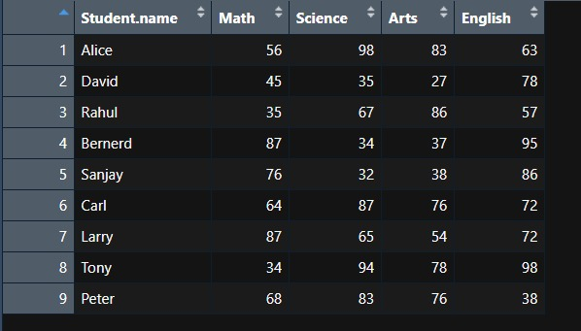

*Data set table in R script*

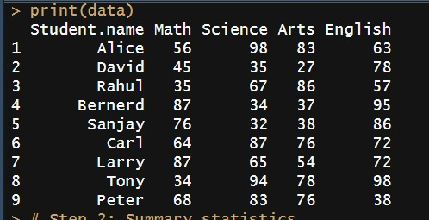

*Data set in Console/Terminal*

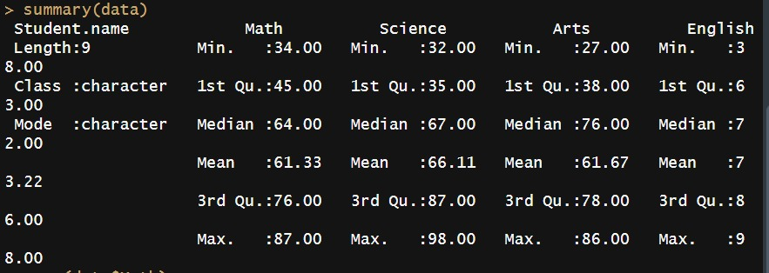

*Summary Output of the Data set*

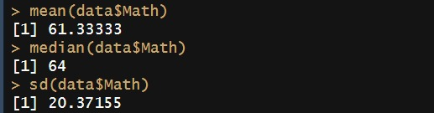

*Statistical Results of the Data Set*

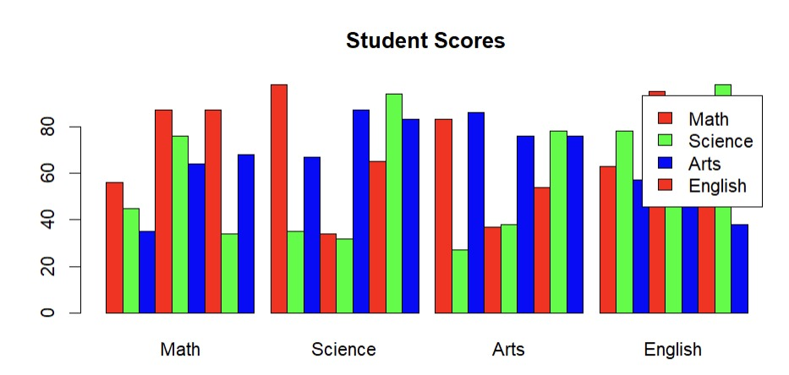

*Bar Plot Chart of Students*

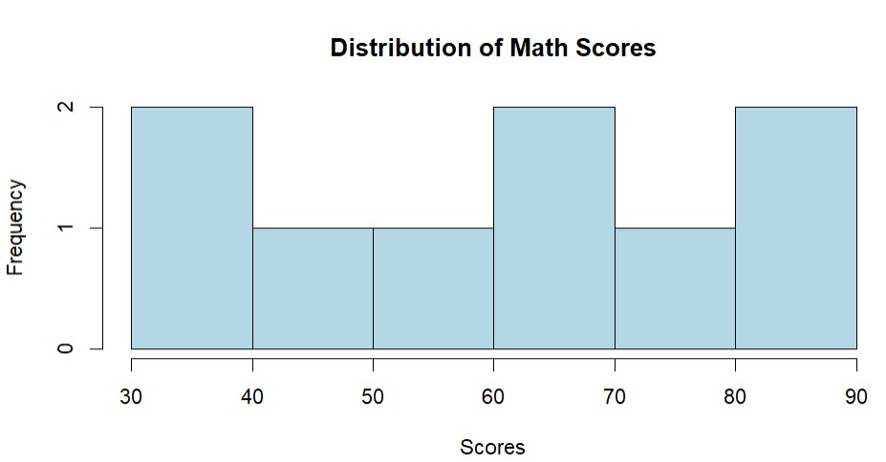

*Histogram Of Math Subject*

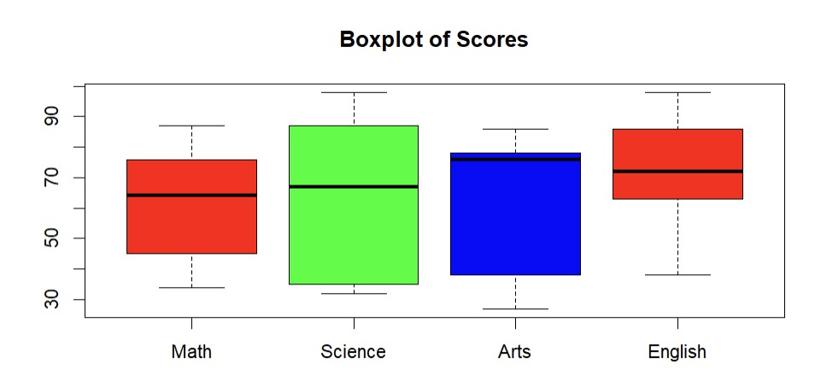

*Box Plot Chart of Students*

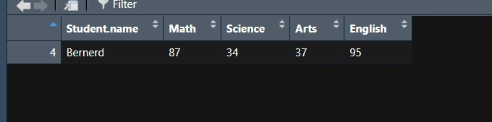

*Highest Marks of math (Mode)*

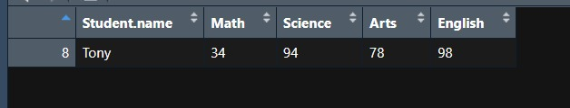

*Lowest Marks of Math*

**7. Learning Outcomes**

* Gained hands-on experience with importing and analyzing data using R.
* Understood how to apply statistical functions like mean(), median(), and sd() to real-world data.
* Learned how to visualize data effectively using bar plots, histograms, and box plots.
* Practiced interpreting visual and statistical output to extract meaningful insights.
* Developed a better understanding of how data analysis can support academic performance evaluation.

**8. Conclusion**  
  
This project successfully analyzed and visualized student performance using R. It demonstrated how statistical functions and plots can help interpret educational data, allowing educators to quickly assess trends and identify outliers for improvement.